ATDP CONTINUING PROFESSIONAL DEVELOPMENT STEP-BY-STEP GUIDE

1. There are two methods of accessing the CPD Portal.
a. Via the ATDP Home Page. Log in to the ATDP Home Page as normal, then click on the green ‘Log in to your CPD home page” tab. You will be taken to the CPD Home Page. Note that the ‘Welcome’ button shows you are automatically logged in to the CPD Portal.
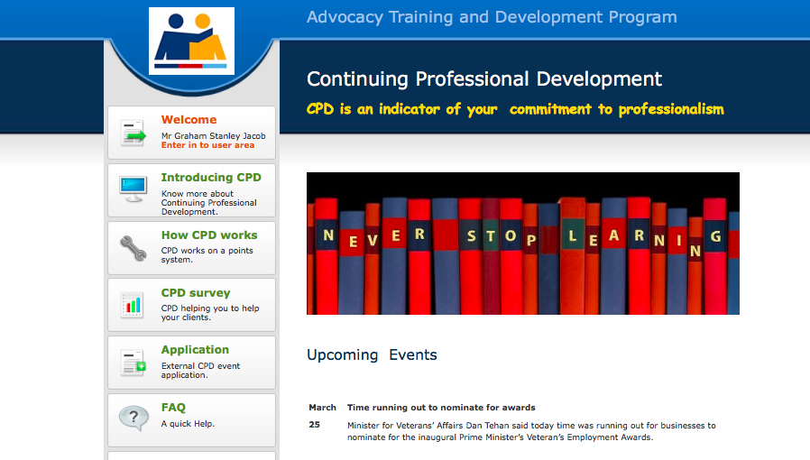
b. Via any Internet Browser. Type ‘atdp.org.au/cpd’ into the command line of your internet browser. You will be taken to the CPD Home Page. Note that the ‘Log in’ button shows that you will need to log in to the CPD Portal.
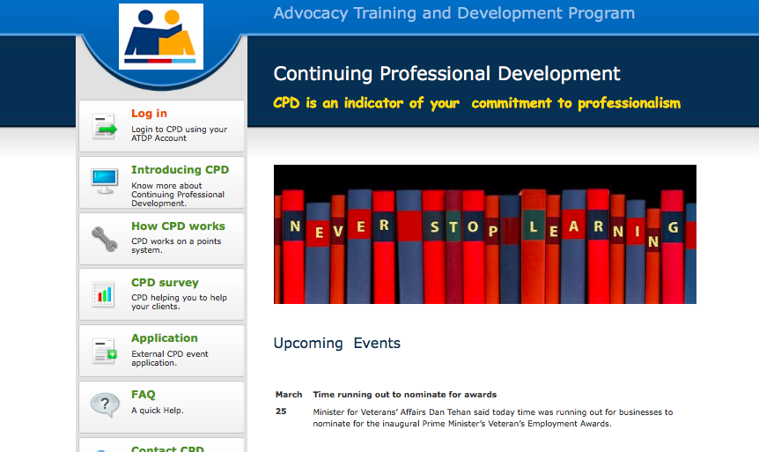

First Time Users
2. It is recommended that you save the page to your Bookmarks or Favourites for easier access in future.
3. Click on the ‘Introducing CPD’ tab on the left-hand side of the screen and read the information. When finished, use your browser’s ‘Back’ button to return to the CPD Home Page.
4. Click on the ‘How CPD Works’ tab on the left-hand side of the screen and read the information. When finished, use your browser’s ‘Back’ button to return to the CPD Home Page.
5. Click on the ‘FAQ’ tab on the left-hand side of the screen and read the questions and answers. When finished, use your browser’s ‘Back’ button to return to the CPD Home Page.
Log in to Your Personal CPD Home Page
Note: If you are already logged in, skip this step and proceed to paragraph 8.
6. Click on the ‘Log in’ tab on the left-hand side of the screen.
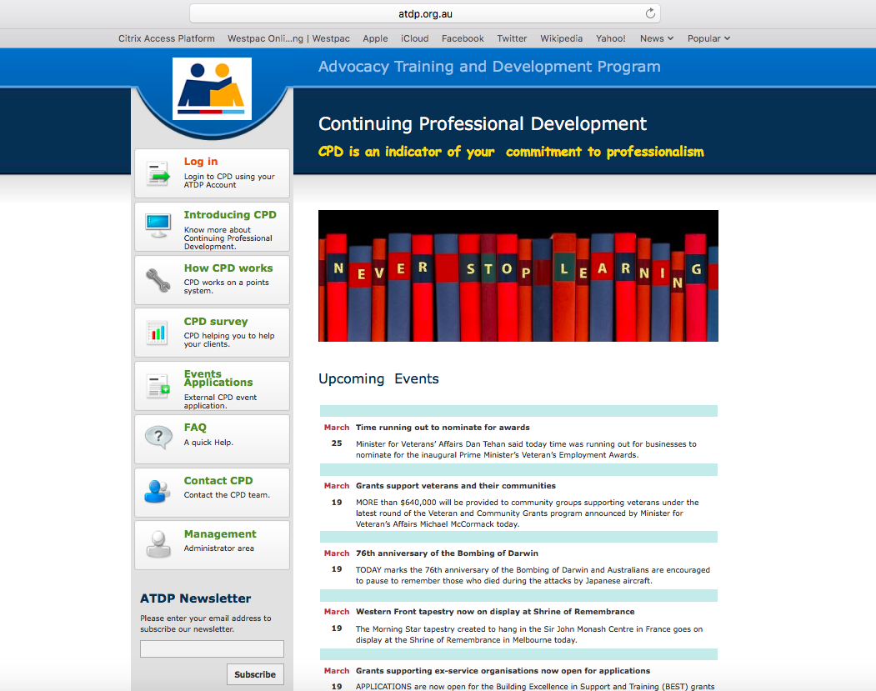
7. The Log in page will open. Enter your ATDP User Name and Password (the same one you use for the ATDP website). If desired, select the ‘Remember me’ box (only select this option if you are the sole user of the computer or device). Click on the purple ‘LOGIN’ button.
Please note:

On logging into your CPD home page, a dialogue box will be displayed requesting you to update your personal details.
Click on the link and update your details as required. There is no drop down menu for either Suburb or Postcode. You will need to enter this information manually.
On completion, don’t forget to hit the UPDATE TAB.
This is a once only operational request. Once you have updated your details, these will be saved automatically to your CPD as well as ATDP profile. The next time you access your CPD profile, the update request will Not be shown again.
If at any time in the future, you change your personal or address details, you can update these by accessing the relevant tab on the ATDP home page.

8. Your individual CPD details will be displayed.

1
2
3
4
5
6
7

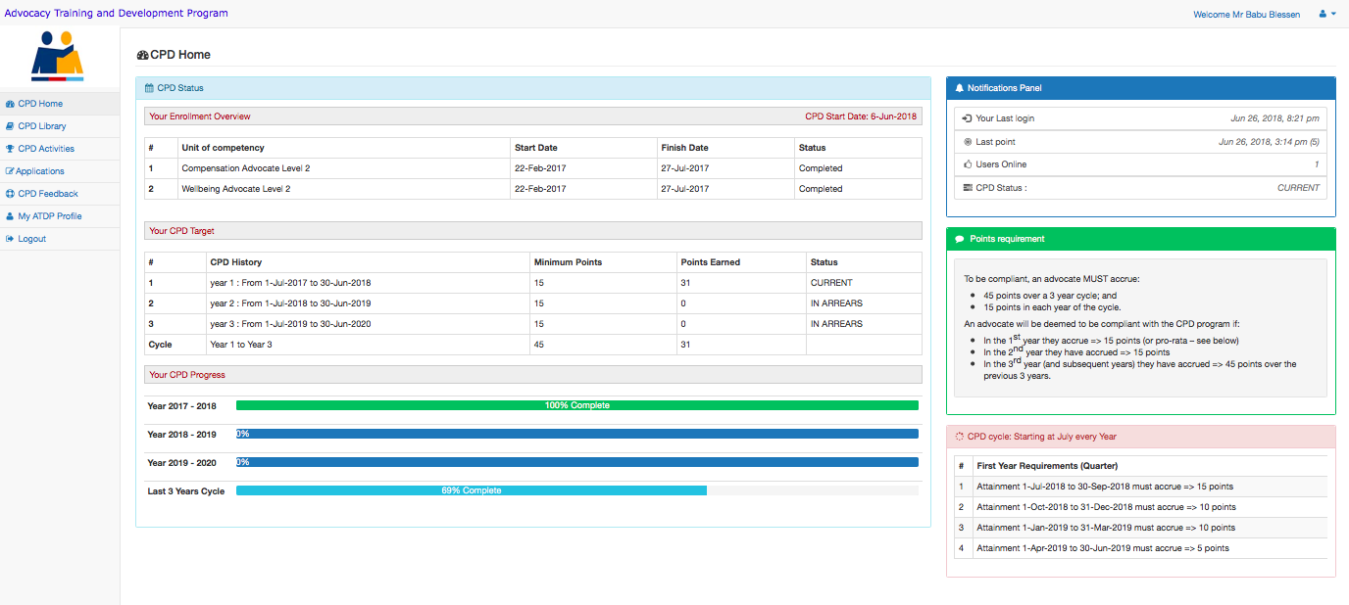
9. Details displayed are as follows:
1. CPD Menu.
2. Your Enrolment Overview. Displays the Units of Competency you have completed or are enrolled for.
3. Your CPD Target. Displays your CPD points targets for the current year and for the 3-year rolling cycle.
4. Your CPD Progress. Displays a live chart of your progress both annually and by 3-year cycle.
5. Notifications Panel. Displays your last login to the CPD portal, the last CPD points you earned, the date you enrolled and your current status (Current, In Arrears or Not Current).
6. Points Requirement. Explains the points required to be maintain a status of ‘Current’.
7. CPD Cycle. Displays your points requirement to maintain CPD currency over a 3-year cycle.

10. Click on the ‘CPD Library’ tab on the left of the screen. The available CPD Activities are displayed, along with the points allocated for successful completion of each.
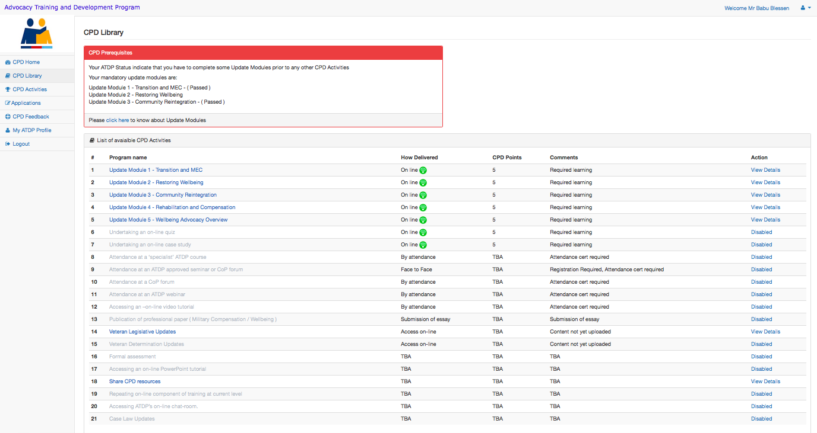

NOTE 1. During the first CPD Year, all Advocates who have achieved their competency through the RPL Pathway will need to complete some compulsory ‘Year 1 CPD Update Modules’. The program consists of:
- Module 1 - ADF Transition Process and Medical Employment Classification System
- Module 2 - Community Reintegration
- Module 3 - Restoring Wellbeing (The Veteran and Family in Crisis)
and either
- Module 4 - Rehabilitation and Compensation Overview for Wellbeing Advocates, or
- Module 5 - Wellbeing Advocacy Overview for Compensation Advocates
NOTE 2. If you have successfully achieved both Welfare and Compensation Level 2 competencies through RPL, there is no need to complete either of the Overview Modules (although you are most welcome to). However, you will still need to achieve 15 CPD points in the first year of CPD activities, so completion of other CPD activities may be required.
NOTE 3. Most of the CPD Activities in the Library are not available (greyed out) until you have completed the required Update Modules. Once these have been completed, the other Activities will become available.
Completing CPD Update Modules
11. Click on one of the CPD Update Modules in the CPD Library. A PowerPoint presentation will open. Ensure that your computer or device has sound enabled and the volume adjusted, as all of the Update Modules have a narration with each slide. Click the ‘Next’ and ‘Prev’ buttons to move forward and backward through the presentation. If the narration does not commence automatically, click on the ‘Next’ and then the ‘Prev’ buttons.
12. At several points in each Module, you will be asked a number of revision questions. It is recommended that you answer these questions, then review your answers by going back over the preceding slides.
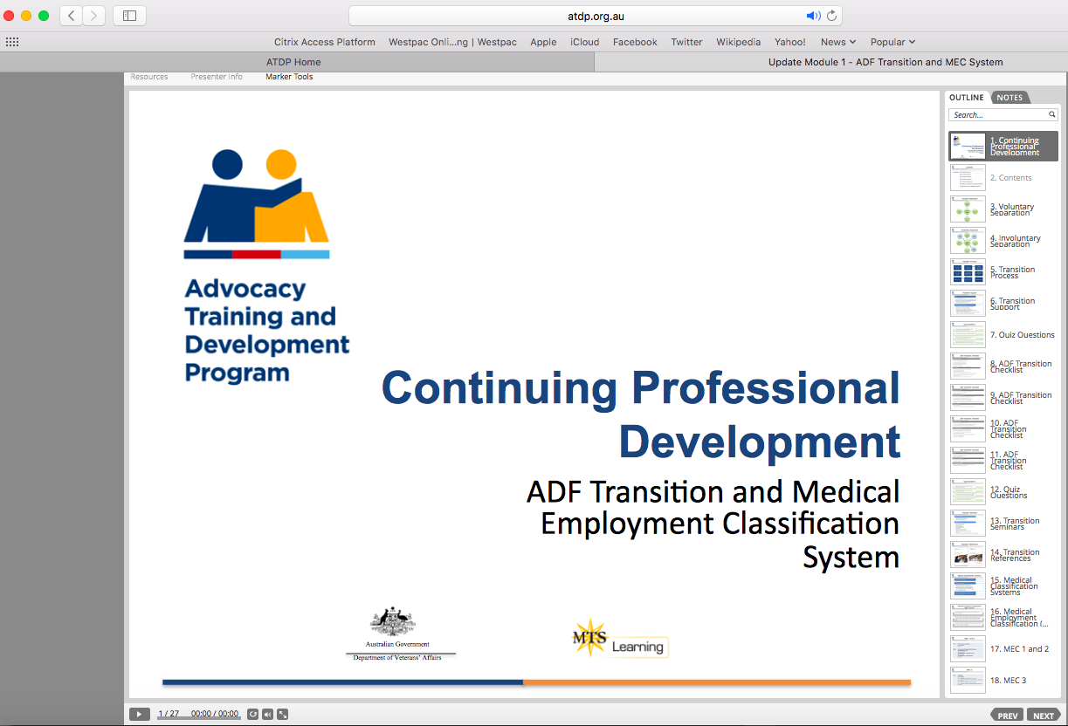
13. When you have completed the entire CPD Update Module, return to the CPD Library and open the Online Quiz for the Module (the questions are the same as the revision questions asked during the presentation). The quiz for some Modules have 15 questions, worth 1/3 of a point each, while some have 10 questions, worth 1/2 point each. You will need to achieve 100% for the quiz to earn 5 CPD points. You may attempt the quiz more than once
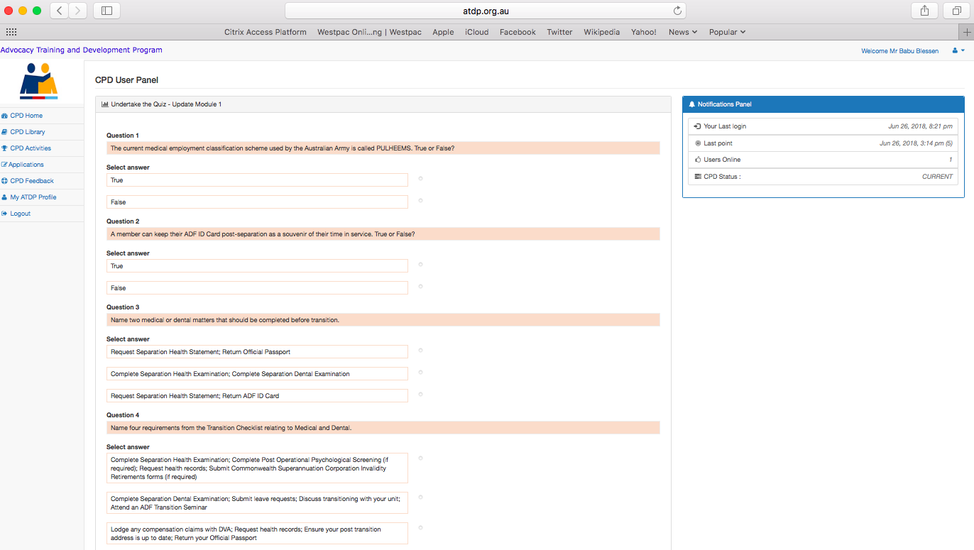
14. When you have completed the Quiz, your CPD points will automatically be allocated to your CPD profile.

